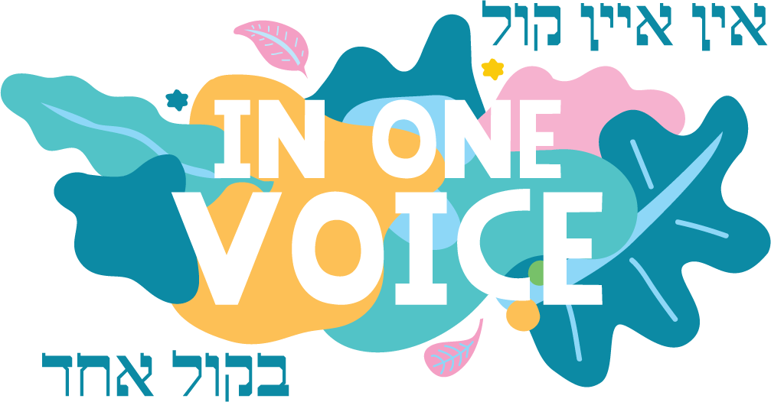
w: inonevoice.org.au
e: withonebrush@gmail.com

Dear art teacher,

The “In One Voice” Jewish Street Festival is proud to announce that the “With One Brush” Art Exhibition and Competition will be held this year on Sunday 15 March 2020. The exhibition aims to showcase the wonderful and creative talents within our Melbourne Jewish community.
In 2019, the “With One Brush” Art Exhibition will once again have two divisions:
- School Children – Grades 4 to 6; Years 7 to 9; and Years 10 to 12
- Adults
We would like you to promote the Exhibition and Competition at your school and encourage the art department to get behind this exciting opportunity to show off your students’ talents.

Requirements
- Grade 4 to 6 – submission of 5 artworks only in age group
- Grade 7 to 9 – submission of 5 artworks only in age group
- Grade 11 to 12 - submission of up to 10 artworks in age group
- Works can be 2D or 3D.
- All 2D artwork must be ready to be hung on the day
- There is no cost for student entries

Categories
There are 3 sections
- Senior School and VCE students from year levels 10 – 12
- Secondary School Students from year levels 7 – 9
- Primary School Students from grades 4 – 6
The works will be judged by a well-known member of the art community and all work will be displayed at the “With One Brush” Art Exhibition on Sunday 15th March 2020.

Prizes
Prizes of merit shall be awarded in each section. Judging and awards will be announced on the day of the festival.
Due Date
Please ensure entry forms are sent by Friday 28th February 2020.

If you have any queries, please email us at withonebrush@gmail.com. After hours you can call Nastassja on 0478 023 155.

We look forward to showcasing your students’ artwork at this year’s Exhibition.

Nastassja Kuran

With One Brush Art Exhibition Coordinator

