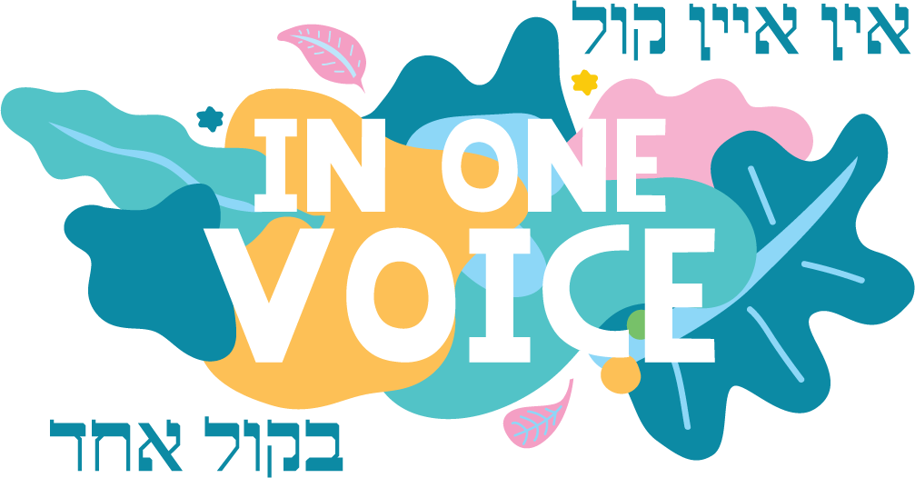
w: inonevoice.org.au
e: withonebrush@gmail.com

WITH ONE BRUSH ENTRY FORM – Individual Student
To be completed and returned to the organisers by
Friday 28th February 2020.

STUDENT DETAILS
Name of Artist
Year Level
School
Address
Contact Numbers
Email Address

ARTWORK DETAILS
Artwork Title | Artwork Type  (Painting, Photography, sketching, drawing, sculpture etc.) | Size of Artwork  (approx.)
1.
2.
3.
4.

WITH ONE BRUSH: TERMS & CONDITIONS
- Painting and print works should be suitably finished and ready for hanging, provided with screw eyes and hanging wire. Contact details (name, year level and school) must be clearly labelled on the back of each piece of artwork.
- All artwork must be delivered to the IOV Festival at Sholem Aleichem College Elsternwick, 11 Sinclair Street Elsternwick 3185 between 9:30am and 12.30pm on Friday 13th March, 2020. The Art Exhibition will be held in the industrial chic surrounds of the former ABC site in Selwyn St, Elsternwick. Arrangements will need to be made for anyone who cannot deliver on this day by contacting Nastassja on 0478 023 155.
- All works must be collected by 5 pm on Sunday 15^{h} March 2020 from the exhibition site.
- The Organisers will exercise all reasonable care in handling the artworks accepted, but will not be responsible for the loss of or any damage to any works while in the custody of the Organisers. Insurance against damage, fire and theft on individual works whilst in the Organiser's custody or in transit is the Artist’s responsibility.
- The organisers reserve the right to display the submitted works throughout the duration of the exhibition in such manner as they may choose. No discussion or correspondence will be entered into on this point.
- The Artist appoints the Organisers as his or her agents for all purposes associated with the exhibition.
- The Organisers shall have the right to photograph paintings and publish those photographs for publicity purposes.
- All accepted artwork will be eligible for prizes as per categories detailed on attached letter. The Organisers’ and Judges' decisions are final.

I hereby agree to the above Terms & Conditions of the “With One Brush” Art Exhibition
Name of Student _______________________________
School: _______________________________
Signature: _______________________________
Date: _______________________________

